**Globalization of the U.S. Banking System**

The globalization of the U.S. banking system has transformed how financial institutions operate, interact, and impact economies worldwide. Key aspects and their implications include:

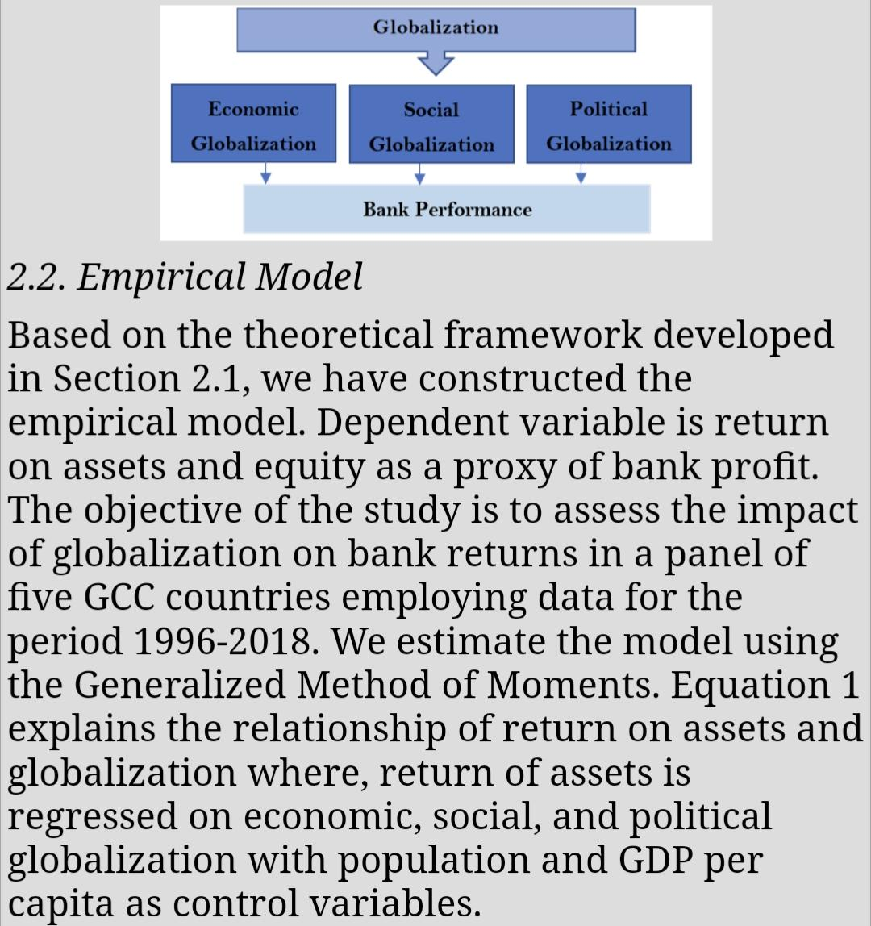

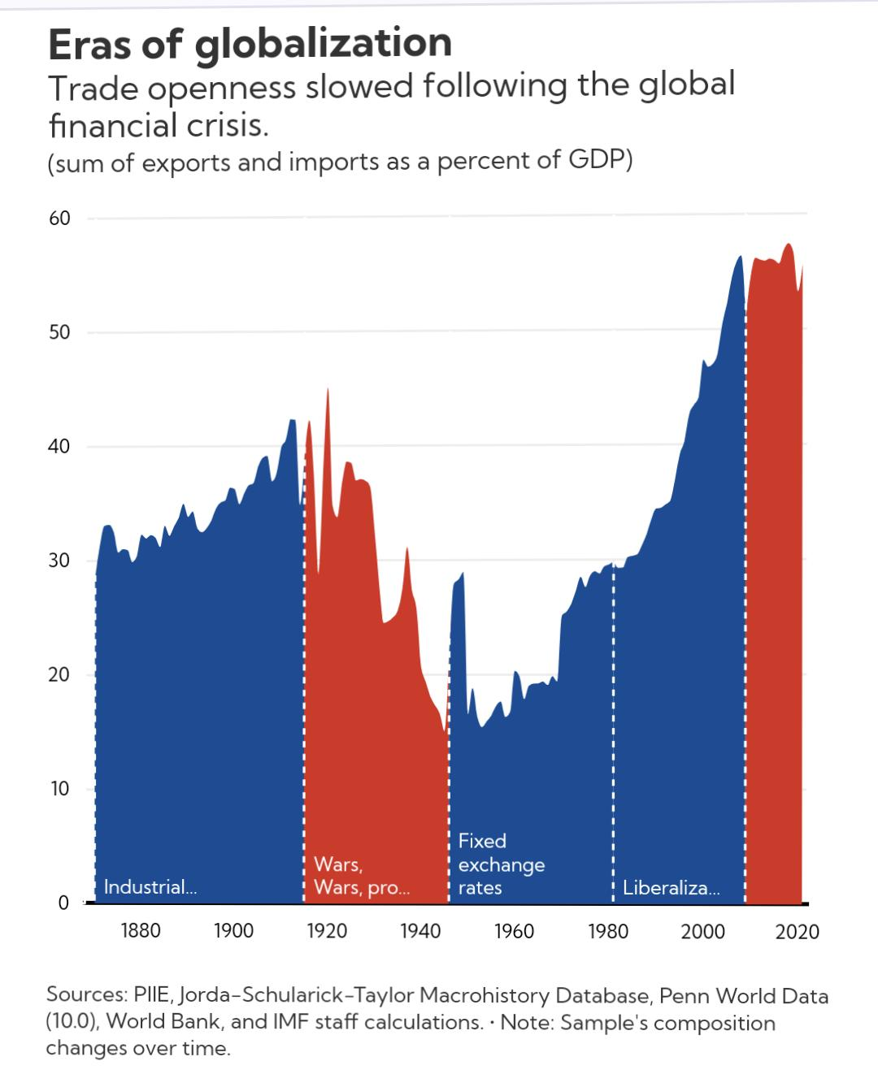

Each of the chart’s five main periods was characterized by different configurations of economic and financial powers, and different rules and mechanisms for economic and financial ties between countries.

**Key Aspects**

**Cross-Border Expansion:**

Global Operations: Major U.S. banks like Citibank, JPMorgan Chase, and Bank of America have established extensive international networks, offering services to clients worldwide.

Mergers and Acquisitions: U.S. banks have acquired foreign banks and entered joint ventures to expand their global footprint.

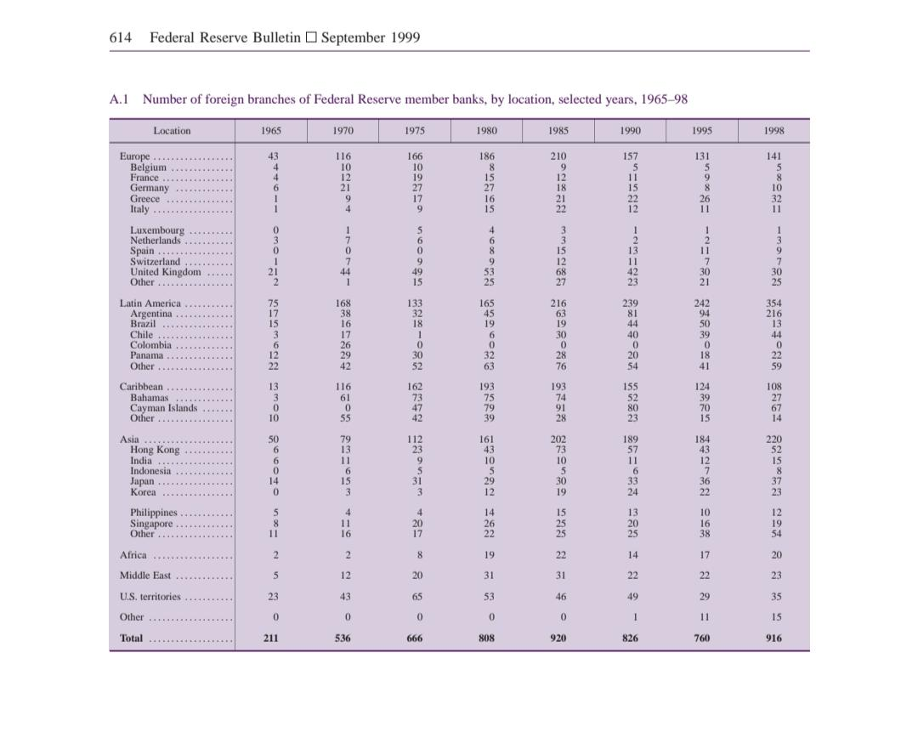

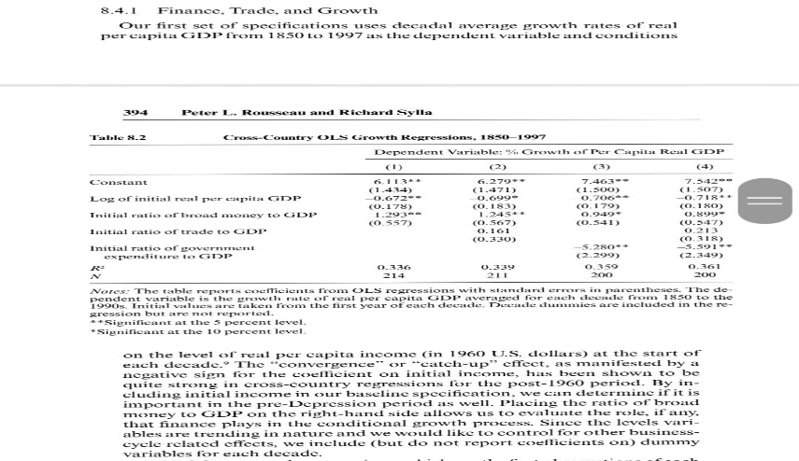

**Technological Advancements**: Digital banking platforms enable seamless international transactions and access to financial services globally. U.S. banks have been at the forefront of adopting technologies like mobile banking, blockchain, and AI, facilitating global financial integration.

**Regulatory Harmonization**: The adoption of international regulatory frameworks like Basel III has aimed to enhance financial stability and risk management across borders. U.S. banks comply with various international regulations to ensure consistent oversight and reduce systemic risk.

**Capital Markets Integration**: U.S. banks are major players in global capital markets, facilitating cross-border investments and trade. The securitization of financial assets and their sale to international investors help spread risk and provide liquidity.

**Effect of globalisation**

Banking system globalization has evolved over several decades, driven by deregulation, technological advancements, and regulatory harmonization. It has profoundly impacted corporate and investment banking, retail banking, SMEs, real estate, technology, and regulatory sectors. The most affected sectors include corporate and investment banking due to increased cross-border activities, and technology due to the rise of fintech innovations. This integration has facilitated economic growth, improved access to financial services, and driven innovation, while also posing regulatory and systemic risk challenges.

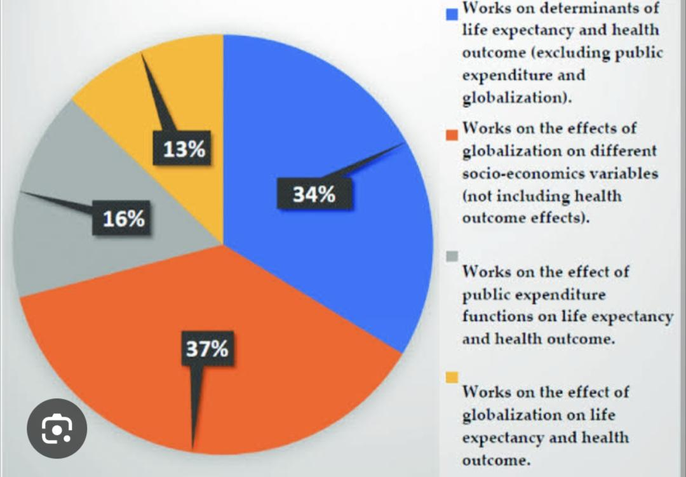

**Financial inclusion initiatives by US banking systems**

In the age of globalization aim to bridge the gap for underserved communities. Here are some key areas of focus:

**Promoting financial literacy**: Educational programs and resources help individuals make informed financial decisions and navigate the banking system.

**Tailoring products and services**: Banks are developing new account types, loan products, and other financial services that cater to the specific needs of unbanked and underbanked populations.

**Community outreach**: Building trust and relationships with underserved communities is essential for promoting financial inclusion. This can involve partnering with community organizations and providing culturally relevant financial products and services..

**Impact of Financial Inclusion During Globalization**

**Economic Empowerment:** Financial inclusion initiatives empower individuals with the tools to participate in the economy, save money, and invest in their future.

**Poverty Alleviation**: Access to financial services helps reduce poverty by enabling individuals to manage their finances, access credit, and build assets.

**Economic Growth**: Inclusion leads to broader economic growth as more individuals engage in entrepreneurial activities and contribute to the economy.

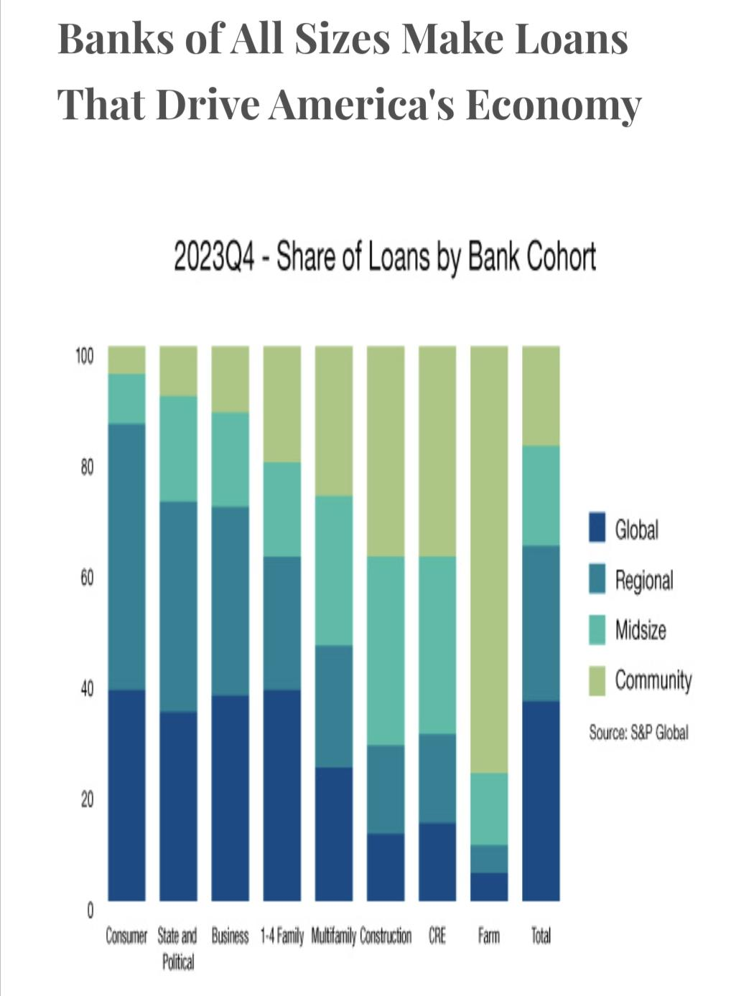

**Stability and Resilience:** Financially included populations are better equipped to withstand economic shocks and recover from financial crises, contributing to overall economic stability.

**Global Influence**: U.S. banks’ adoption of global standards and practices influences international financial inclusion efforts, promoting broader access to financial services worldwide.

**Expanding access to digital financial services**: This includes mobile banking, online account opening, and digital payments. Fintech partnerships and initiatives are helping to make these services more accessible and affordable

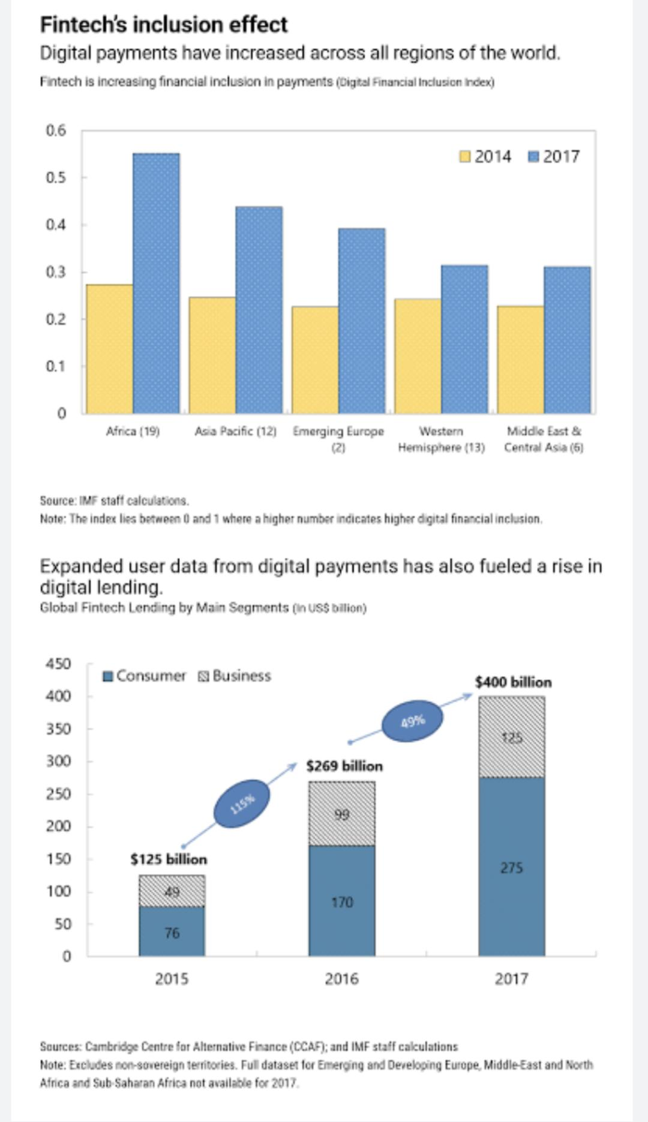

**Emerging Trends in the U.S. Banking Sector**

Several trends are shaping the future of the U.S. banking sector:

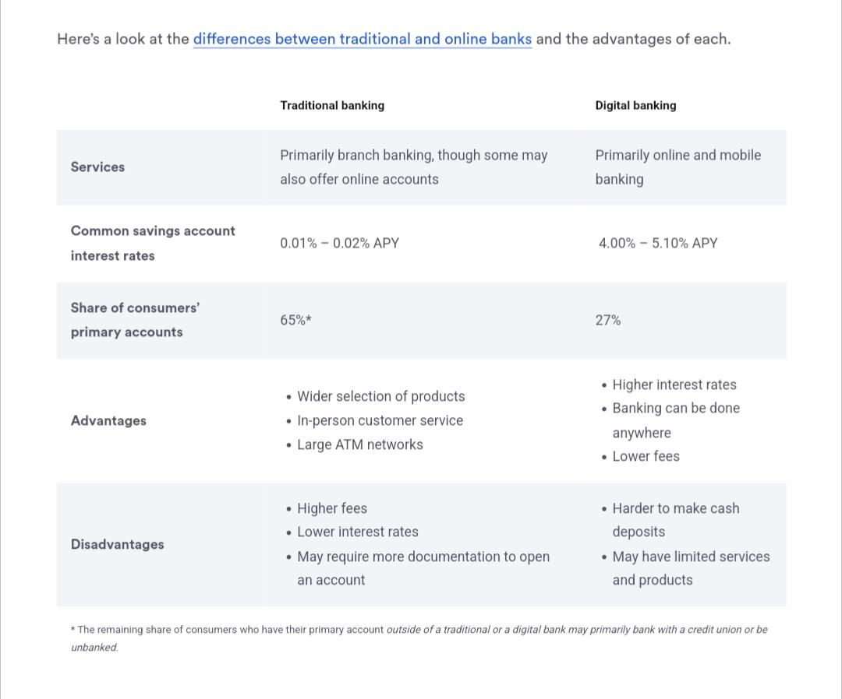**Digital Transformation:** Banks are increasingly investing in digital technologies to enhance customer experience, streamline operations, and reduce costs. This includes the use of AI for customer service, blockchain for secure transactions, and advanced analytics for personalized banking services.

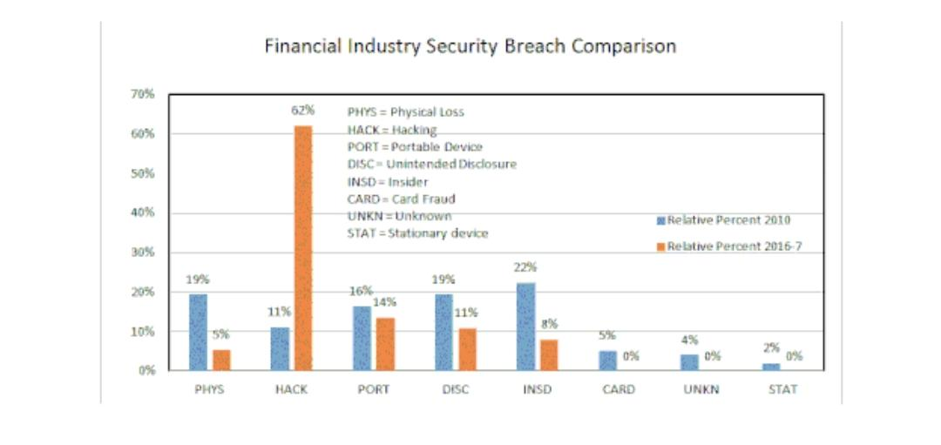**Cybersecurity**: As digital banking grows, so does the need for robust cybersecurity measures. Banks are investing heavily in technologies to protect customer data and prevent fraud.

**Regulatory Changes**: The regulatory landscape is evolving, with a focus on enhancing financial stability, consumer protection, and transparency. Banks need to stay compliant with new regulations while adapting to market changes.

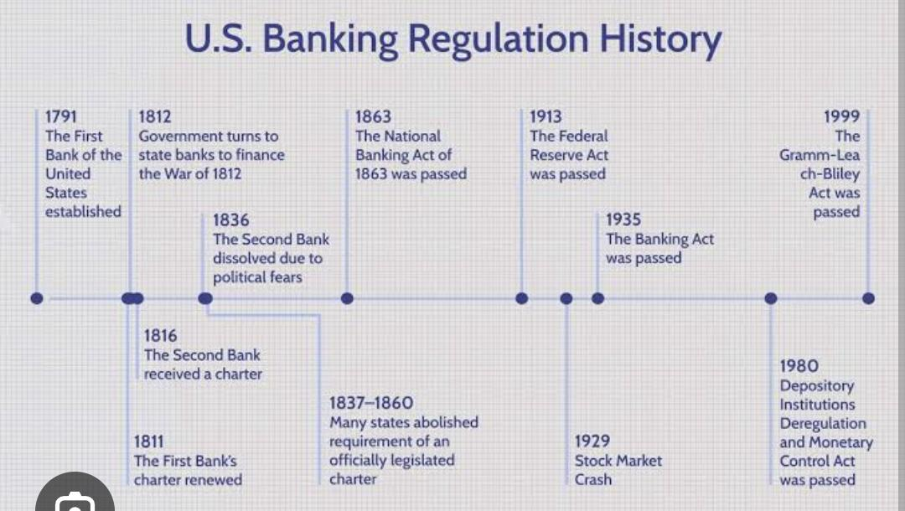

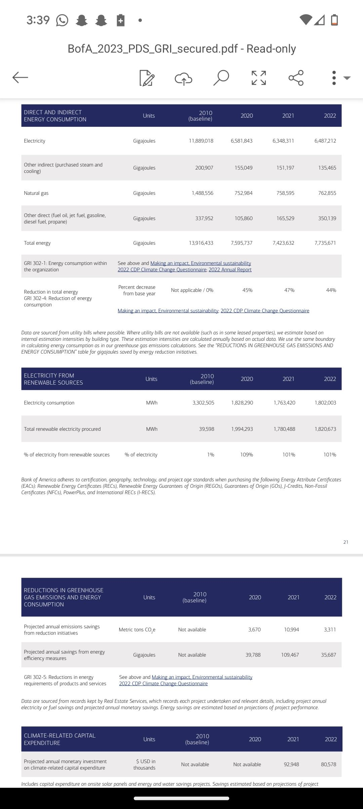**Sustainability and ESG Investing**: There is a growing focus on environmental, social, and governance (ESG) criteria. Banks are developing products and services that promote sustainable investments and support green initiatives.

**Open Banking:** The push towards open banking, where banks share customer data with third-party financial service providers (with customer consent), is fostering innovation and competition. This trend is expected to lead to more personalized financial products and services.

